REACT HANDS ON 11

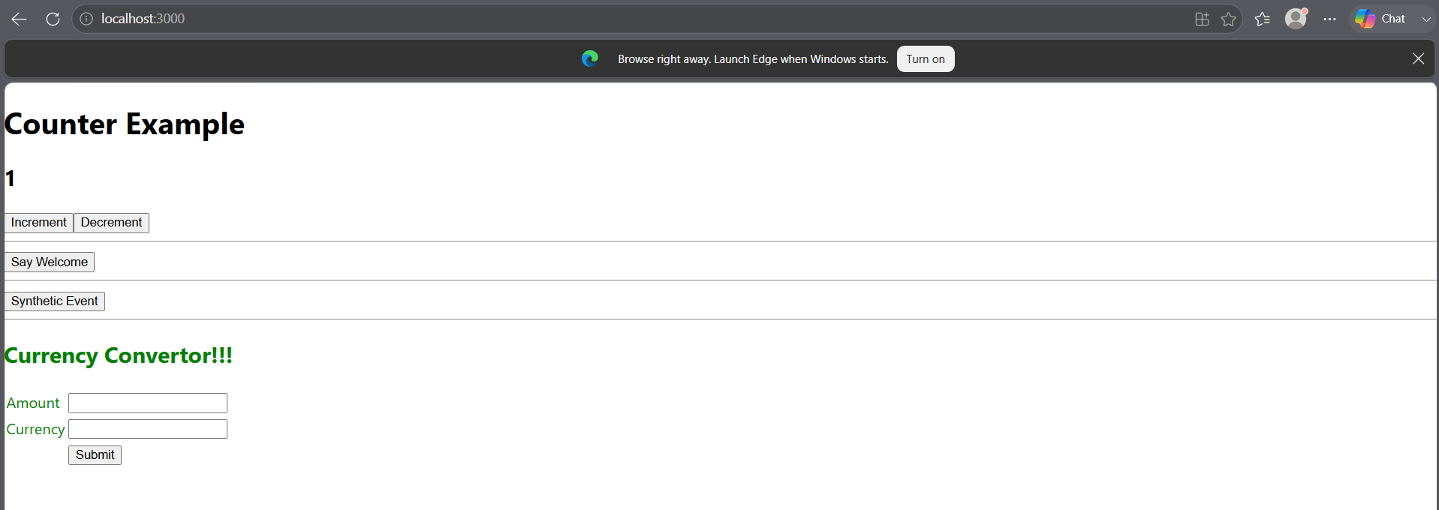

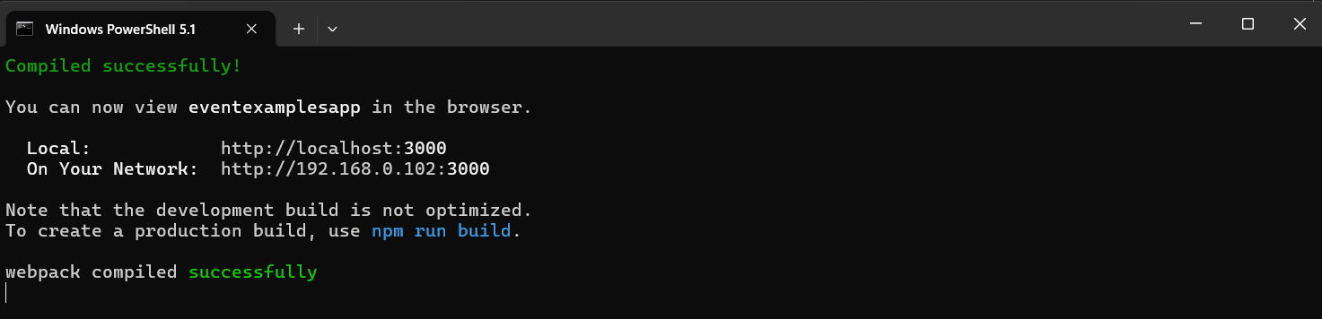

CURRENCYCONVERTOR.JS
import React, { useState } from 'react';

function CurrencyConvertor() {

const [amount, setAmount] = useState('');
const [currency, setCurrency] = useState('');

const handleSubmit = () => {

let euro = amount / 90;

alert(
amount +
" INR = " +
euro.toFixed(2) +
" Euro"
);
};

return (
<div style={{color:'green'}}>

<h2>Currency Convertor!!!</h2>

<table>
<tbody>

<tr>
<td>Amount</td>
<td>
<input
type="text"
value={amount}
onChange={(e)=>
setAmount(e.target.value)
}
/>
</td>
</tr>

<tr>
<td>Currency</td>
<td>
<input
type="text"
value={currency}
onChange={(e)=>
setCurrency(e.target.value)
}
/>
</td>
</tr>

<tr>
<td></td>
<td>
<button onClick={handleSubmit}>
Submit
</button>
</td>
</tr>

</tbody>
</table>

</div>
);
}

export default CurrencyConvertor;

